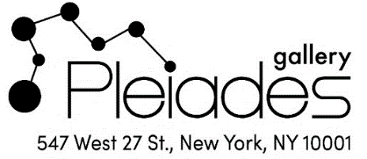

FOR IMMEDIATE RELEASE Contact:
Heather Stivison Contemporary Art Studio
973.476.9728
Heather@HeatherStivisonArt.com
Images on request

Pleiades Gallery to Celebrate 50th Anniversary

Pleiades Gallery, one of the oldest and most established cooperative galleries in New York City, announces their 50th Anniversary Celebration. A reception will be held at the gallery on Saturday, May 18, 3:00-6:00 pm. The centerpiece of the celebration will be the 50th Anniversary Celebration Exhibition to take place May 14 - June 8 at Pleiades Gallery, 547 West 27th Street, Suite 304..
The exhibition will feature selected works from a group of fourteen of the Gallery’s current roster of members: Leda Arensberg, Frederick Ballet, Ellen Bradshaw, Len DeLuca, Barbara Fracchia, David Hathaway, Lisa Ocasio Hirkaler, Sribee Hunter, Ann Kraus, Carol Nussbaum, Joseph O’Neill, Mitchell Rodbell, Heather Stivison, and Joyce Weidenaar. The variety of works presented will include oil and acrylic paintings, photography and photography based digital art, and digital drawing, in the wide range of styles for which Pleiades is well-known.
Pleiades Gallery first opened its doors in SoHo in 1974, as part of the ''alternative space movement'' –a movement art critic Lawrence Alloway described as being inspired by artists’ yearning “to exercise greater control over the selection of art for public display and the conditions under which it is shown”
-more-
and to “take their own destiny into their own hands.” Pleiades Gallery was originally founded in SoHo by a group of like-minded artists, who wanted to create and exhibit art without the constraints of the commercial galleries of the time.
Highlights from Pleiades’ remarkable 50-year history have been assembled into a scrapbook which includes images of materials now held in the Smithsonian Archives of American Art, and photographs of past speakers such as Merce Cunningham, John Cage, Christo, and Harold Rosenberg. The scrapbook will be available for viewing during the entire exhibition and may also be downloaded from the Gallery’s website at https://www.pleiadesgallery.com/50th-anniversary . Artists, art collectors, and members of the public are invited to share their own memories of the Gallery’s past exhibitions and events, which will be posted on the website and on social media.
# # #
About Pleiades Gallery
Spanning 50 years, Pleiades Gallery is one of the oldest and most well-established galleries in New York City. Founded in Soho in 1974 by a group of like-minded artists, the gallery moved to the heart of Chelsea in 2000 half a block from the High Line, located among the most prestigious galleries in Manhattan. Pleiades Gallery has developed into a Chelsea institution with high standards that are continuously refreshed by new artists representing a diversity of styles, ages and viewpoints and that are creating work across a broad range of mediums.

Gallery Hours: Tuesday through Saturday, 12-6 p.m.

